Assignment given on 4th of February, 2024

1. Create a table named person with fields id, name, city, age, email, country using the following constraints.

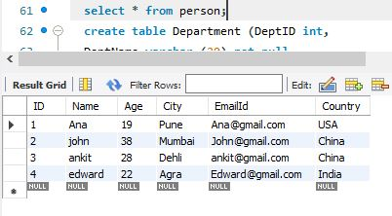

2. Create both table and perform the following operations

Employe Table

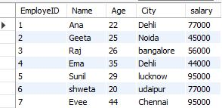

Department Table

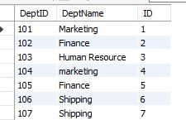

From the above table solve the following

i) Write a query to display the  name of the employee who works in the shipping department.

Ans:- **Select * from Department where DeptName = "shipping";**

ii) Write a query to display the names of the employees who are not in the Finance department

Ans:- **Select * from department where deptName!= "Finance";**

iii) Write a query to display the name of a department having employees with a salary less than 50000.

Ans:- **select count(*), salary from employe group by salary having count(*)<50000;**

3. Look at the sample table and perform the following questions.

A. Write an SQL query to fetch “FIRST_NAME” from the Worker table using the alias name

<WORKER_NAME>.

Ans:- **select First_name from worker;**

B**.** Write an SQL query that fetches the unique values of DEPARTMENT from

the Worker table.

Ans:- **Select distinct (department) from Worker;**

C. Write an SQL query to print all Worker details from the Worker table order

by FIRST_NAME Ascending.

Ans:- **select * from worker order by first_Name;**

D. Write an SQL query to print details for Workers with the first names “Vipul”

and “Satish” from the Worker table.

Ans:- **select * from worker where First_name like "%l" Or"%h";**

**select * from worker where First_name in ( "Vipul","Satish");**

E. Write an SQL query to print details of workers excluding first names, “Vipul”

and “Satish” from the Worker table.

Ans:- **select * from worker where First_name!= "Vipul"Or "Satish";**

F. Write an SQL query to print details of Workers with DEPARTMENT name as “Admin”

Ans:- **Select * from worker where department ="admin";**

G. Write an SQL query to print details of the Workers whose FIRST_NAME contains ‘a’.

Ans:- **Select * from worker where first_name like "%a%";**

H. Write an SQL query to print details of the Workers who joined in Feb 2021

Ans:- **Select * from worker where joining_date like "%2021-02%";**

I. Write an SQL query to fetch the count of employees working in the department ‘Admin’

Ans:- **select count(*),department from worker group by department;**

J. Write an SQL query to fetch the number of workers for each department in descending

order.

Ans:- **select count(*),department from worker group by department order by**

**department desc;**

K. Write an SQL query to show the first 10 records of a table.

Ans:- **select * from worker limit 10;**

L. Write an SQL query to fetch the departments that have less than five people in them.

Ans:- **select count(*),department from worker group by department having count(*)<5;**

M. Write an SQL query to fetch departments along with the total salaries paid for each of

them.

Ans:- **select sum(salary),department from worker group by department having**

**sum(salary);**

**worker table**

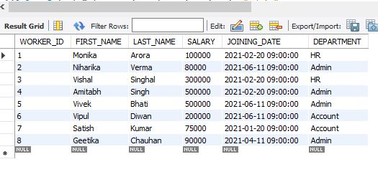

**Bonus Table**

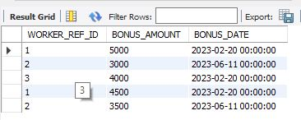

**Title Table**

